

System Analysis and Design

ONLINE BLOOD BANK MANAGEMENT SYSTEM
CS-35

Amira Ali

Team Members:
ID | Student Name | Official E-mail | Level | Department | Section | Contribution
20201700033 | أحمد حسن حسن خطاب | 20201700033@cis.asu.edu.eg | 3 | Computer Science | 1 | We all worked in this task by several online meetings together.
20201700159 | انس سعيد صبري | 20201700159@cis.asu.edu.eg | 3 | Computer Science | 2
20191700875 | أحمد هاني حامد محمد | 20191700875@cis.asu.edu.eg | 3 | Computer Science | 1
20201700488 | عبدالرحمن هاني خيري | 20201700488@cis.asu.edu.eg | 3 | Computer Science | 5
20201700968 | هشام ايمن محمد ابراهيم | 20201700968@cis.asu.edu.eg | 3 | Computer Science | 10
20201701023 | يوسف عماد الدين مسعد علي | 20201701022@cis.asu.edu.eg | 3 | Computer Science | 10

- Project Description and Services in Details:
This project represents a system for an online blood bank , which can used by user.
User can :
- Register : create Account.
- Login.
- Modify his Information.
User has three children (All children can act as user):
- Patient :
which can:
- Search Donors : by typing his requirements e.g.(blood type ,city),then he finds a list of donors that meet the requirements.
- Request Service : by choosing his suitable donor and request his information.
- View Donor Info : when the required donor accepts to view his information , patient can directly access all of his information.
- Get Life Saving Contacts : View Life Saving Contact in case he didn’t find his requirements , or donor refused to share his information.
- Donor :
which only can :
- Accept Requests : Accept requests for viewing his information or refuse.
- Admin :
which is responsible for:
- Manage Requests : between the patient and donor ,and return the Life Saving Contacts to the patient in case donor refused to view his information.

- Use Case Diagram
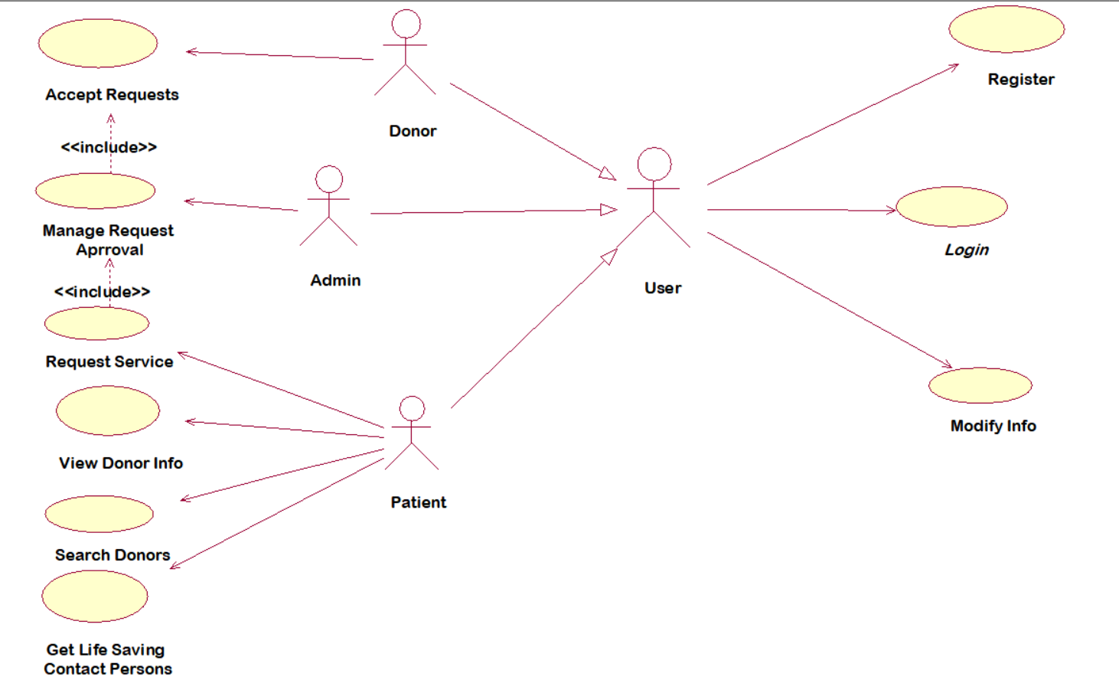
- DFD Diagrams
  - Context Diagram
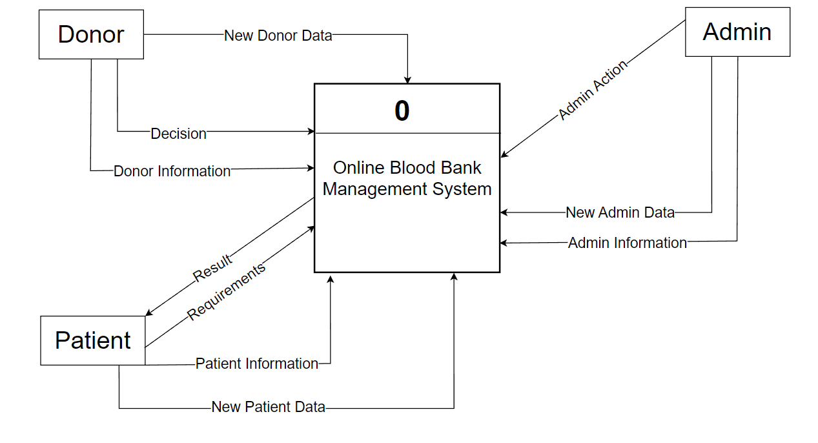
  - Level 0 Diagram
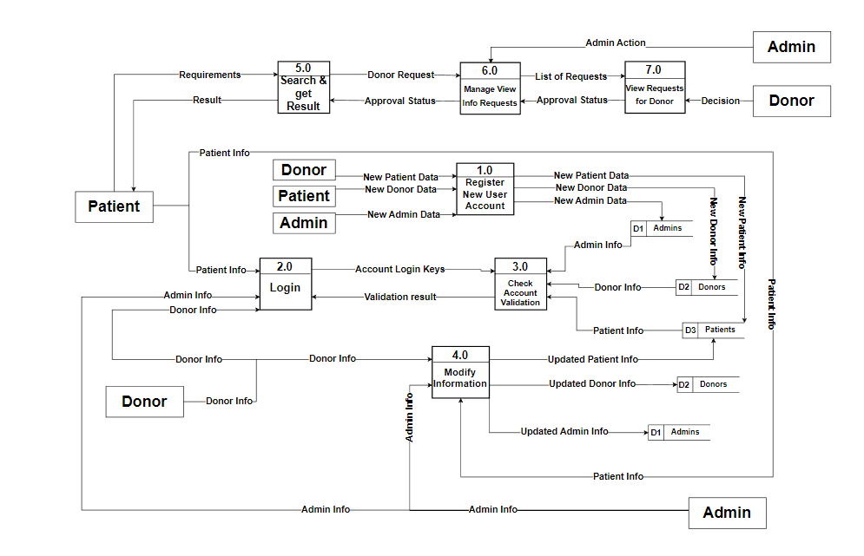
  - Level 1 Diagram
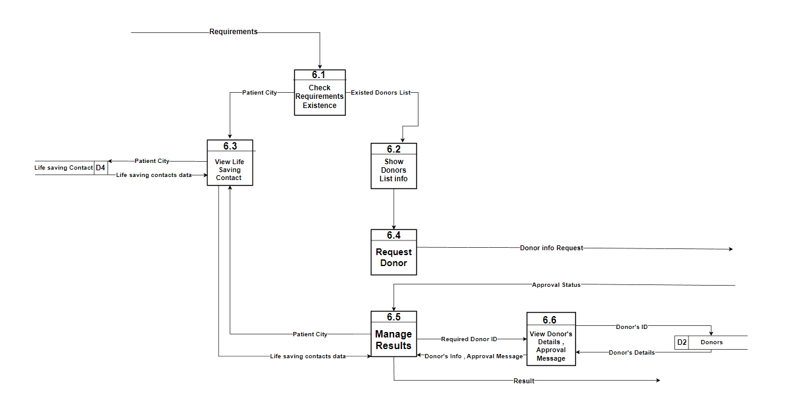
- Class Diagram
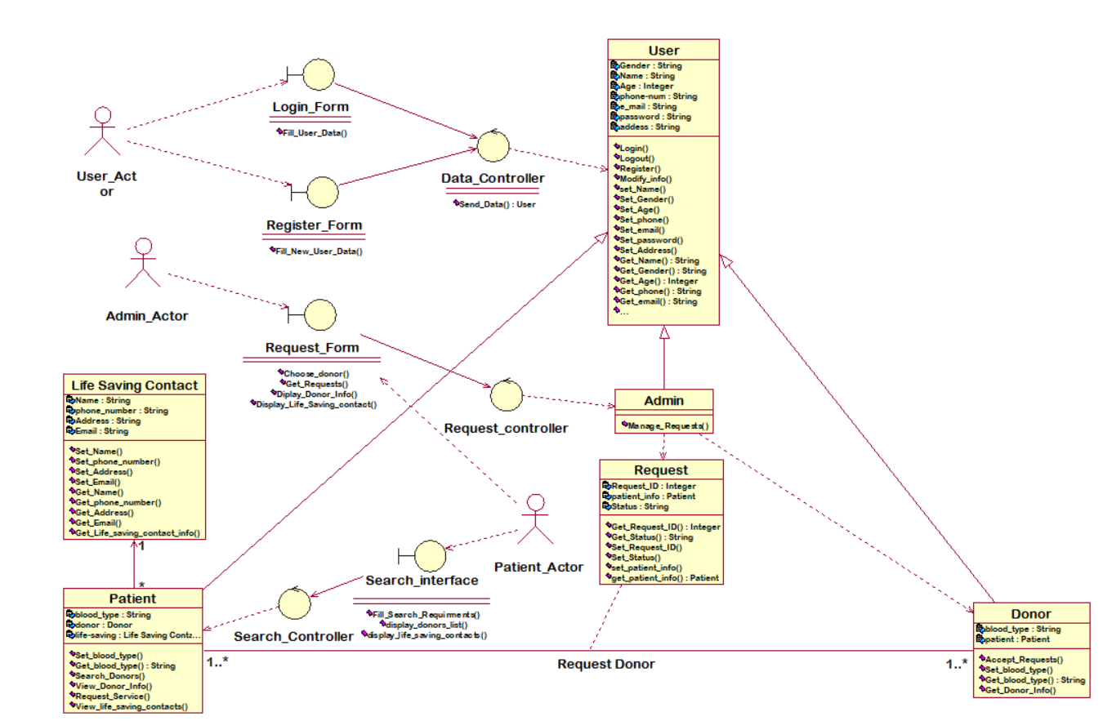
- Sequence Diagrams
  - Search Donors
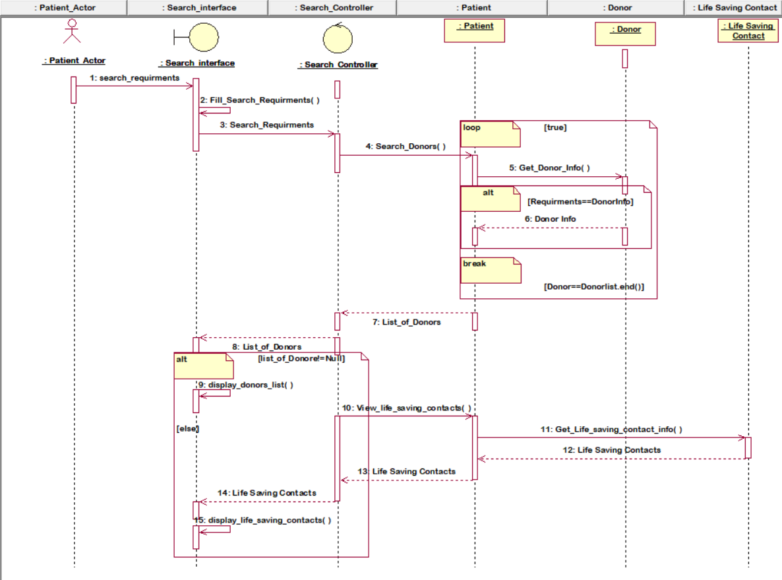
  - Manage Request Approval
